https://jira.tcsbank.ru/browse/IN-1096
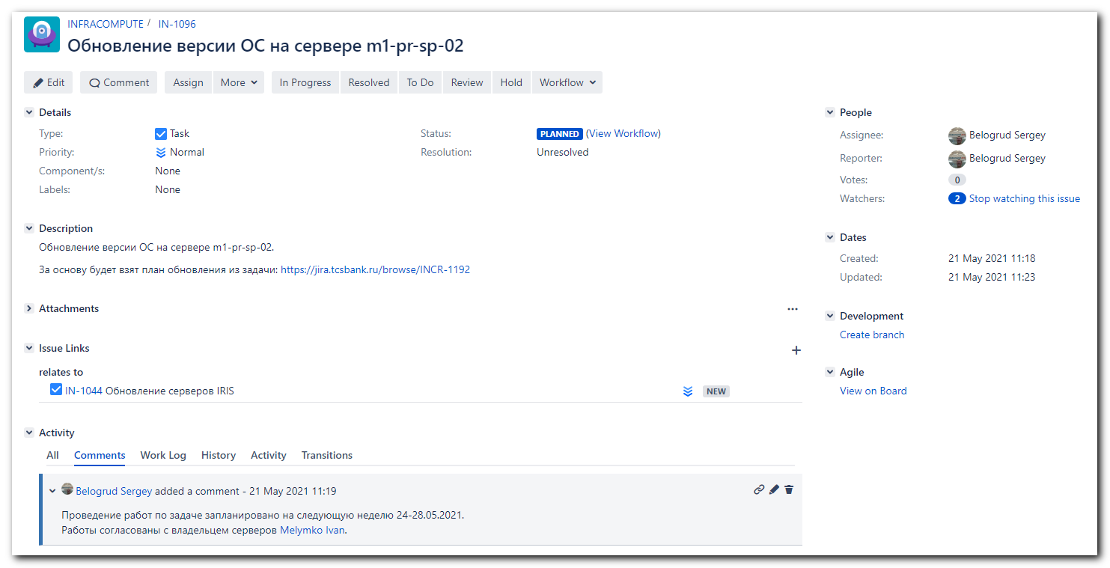

[s.belogrud@nb2339]# ssh s_s.belogrud@m1-pr-sp-02
Creating directory '/home/idm/s_s.belogrud'.
[s_s.belogrud@m1-pr-sp-02 ~]$ sudo -i

We trust you have received the usual lecture from the local System
Administrator. It usually boils down to these three things:

#1) Respect the privacy of others.
#2) Think before you type.
#3) With great power comes great responsibility.

[sudo] password for s_s.belogrud:
[root@m1-pr-sp-02 ~]#
[root@m1-pr-sp-02 ~]# cat /etc/redhat-release
Red Hat Enterprise Linux Server release 7.7 (Maipo)
[root@m1-pr-sp-02 ~]# subscription-manager status
+-------------------------------------------+
System Status Details
+-------------------------------------------+

User interrupted process.
[root@m1-pr-sp-02 ~]# egrep -e "^proxy_hostname|^proxy_port|^proxy_user|^proxy_password" /etc/rhsm/rhsm.conf
proxy_hostname =
proxy_port =
proxy_user =
proxy_password =
[root@m1-pr-sp-02 ~]# vim /etc/rhsm/rhsm.conf
[root@m1-pr-sp-02 ~]# egrep -e "^proxy_hostname|^proxy_port|^proxy_user|^proxy_password" /etc/rhsm/rhsm.conf
proxy_hostname = proxy.tcsbank.ru
proxy_port = 8080
proxy_user = rhsm_user
proxy_password =6eKoEvNHFS5IycxhqH5W
[root@m1-pr-sp-02 ~]#

[root@m1-pr-sp-02 ~]# read -s -p "Enter RHN Password: " RHN_PASSWORD ; subscription-manager register --username=tcsbank17012012 --password=$RHN_PASSWORD --auto-attach
Enter RHN Password: Registering to: subscription.rhsm.redhat.com:443/subscription
The system has been registered with ID: abde1f1e-54a2-4448-aae3-edc57c4d5732
The registered system name is: m1-pr-sp-02.tcsbank.ru
Installed Product Current Status:
Product Name: Red Hat Enterprise Linux Server
Status: Subscribed

[root@m1-pr-sp-02 ~]# subscription-manager status
+-------------------------------------------+
System Status Details
+-------------------------------------------+
Overall Status: Current

System Purpose Status: Not Specified

[root@m1-pr-sp-02 ~]# subscription-manager identity
system identity: abde1f1e-54a2-4448-aae3-edc57c4d5732
name: m1-pr-sp-02.tcsbank.ru
org name: 6534084
org ID: 6534084
[root@m1-pr-sp-02 ~]# subscription-manager release --set 7.9
Release set to: 7.9
[root@m1-pr-sp-02 ~]#

[root@m1-pr-sp-02 ~]# mkdir -p ~/work/20210521-1342/backup
[root@m1-pr-sp-02 ~]# cp /etc/yum.repos.d/* ~/work/20210521-1342/backup/
[root@m1-pr-sp-02 ~]# ls -Alh ~/work/20210521-1342/backup/
total 132K
-rw-r--r-- 1 root root 112K May 21 13:43 redhat.repo
-rw-r--r-- 1 root root 145 May 21 13:43 tcs-centos.repo
-rw-r--r-- 1 root root 150 May 21 13:43 tcs-epel.repo
-rw-r--r-- 1 root root 135 May 21 13:43 tcs-influx.repo
-rw-r--r-- 1 root root 165 May 21 13:43 tcs-ius.repo
-rw-r--r-- 1 root root 185 May 21 13:43 tcs-rhel-server-rpms.repo
[root@m1-pr-sp-02 ~]#

[root@m1-pr-sp-02 ~]# yum repolist --disablerepo="*" --enablerepo="rhel-7-server-rpms"
Loaded plugins: product-id, search-disabled-repos, subscription-manager
rhel-7-server-rpms | 3.5 kB 00:00:00
(1/3): rhel-7-server-rpms/x86_64/updateinfo | 4.0 MB 00:00:00
(2/3): rhel-7-server-rpms/x86_64/group | 631 kB 00:00:00
(3/3): rhel-7-server-rpms/x86_64/primary_db | 81 MB 00:00:02
repo id repo name status
rhel-7-server-rpms/x86_64 Red Hat Enterprise Linux 7 Server (RPMs) 31,775
repolist: 31,775
[root@m1-pr-sp-02 ~]#

[root@m1-pr-sp-02 ~]# yum update --disablerepo="*" --enablerepo="rhel-7-server-rpms"
Loaded plugins: product-id, search-disabled-repos, subscription-manager
Resolving Dependencies
--> Running transaction check
---> Package NetworkManager.x86_64 1:1.18.0-5.el7 will be updated
...
Install 2 Packages (+3 Dependent packages)
Upgrade 273 Packages

Total download size: 379 M
Is this ok [y/d/N]: d
Background downloading packages, then exiting:
Delta RPMs disabled because /usr/bin/applydeltarpm not installed.
...
(277/278): yum-3.4.3-168.el7.noarch.rpm | 1.2 MB 00:00:01
(278/278): zlib-1.2.7-19.el7_9.x86_64.rpm | 90 kB 00:00:01
---------------------------------------------------------------------------------------------------------------------------------------------------------
Total 1.6 MB/s | 379 MB 00:03:53
exiting because "Download Only" specified
[root@m1-pr-sp-02 ~]#

1. Do downtime in nagios.
2. Change root password to default.
3. Reboot the server.
4. Execute yum update.
5. Reboot.
6. Turn off RHN subscription.
7. Change local repository list.

[root@m1-pr-sp-02 ~]# passwd
Changing password for user root.
New password:
Retype new password:
passwd: all authentication tokens updated successfully.
[root@m1-pr-sp-02 ~]#

#
# 20210526
#
[s.belogrud@nb2339]# ssh s_s.belogrud@m1-pr-sp-02
[s_s.belogrud@m1-pr-sp-02 ~]$ sudo -i
[sudo] password for s_s.belogrud:
[root@m1-pr-sp-02 ~]# reboot
Connection to m1-pr-sp-02 closed by remote host.
Connection to m1-pr-sp-02 closed.
[s.belogrud@nb2339]# ssh s_s.belogrud@m1-pr-sp-02
[s_s.belogrud@m1-pr-sp-02 ~]$ sudo -i
[sudo] password for s_s.belogrud:
[root@m1-pr-sp-02 ~]#

[root@m1-pr-sp-02 ~]# ls -Alh /etc/yum.repos.d/
total 132K
-rw-r--r--. 1 root root 112K May 21 13:42 redhat.repo
-rw-r--r--. 1 root root 145 Dec 13 2019 tcs-centos.repo
-rw-r--r--. 1 root root 150 Dec 13 2019 tcs-epel.repo
-rw-r--r-- 1 root root 135 Sep 8 2020 tcs-influx.repo
-rw-r--r--. 1 root root 165 Dec 13 2019 tcs-ius.repo
-rw-r--r--. 1 root root 185 Dec 13 2019 tcs-rhel-server-rpms.repo
[root@m1-pr-sp-02 ~]# ls -Alh ~/work/20210521-1342/backup/
total 132K
-rw-r--r-- 1 root root 112K May 21 13:43 redhat.repo
-rw-r--r-- 1 root root 145 May 21 13:43 tcs-centos.repo
-rw-r--r-- 1 root root 150 May 21 13:43 tcs-epel.repo
-rw-r--r-- 1 root root 135 May 21 13:43 tcs-influx.repo
-rw-r--r-- 1 root root 165 May 21 13:43 tcs-ius.repo
-rw-r--r-- 1 root root 185 May 21 13:43 tcs-rhel-server-rpms.repo
[root@m1-pr-sp-02 ~]# rm /etc/yum.repos.d/tcs-*
rm: remove regular file ‘/etc/yum.repos.d/tcs-centos.repo’? y
rm: remove regular file ‘/etc/yum.repos.d/tcs-epel.repo’? y
rm: remove regular file ‘/etc/yum.repos.d/tcs-influx.repo’? y
rm: remove regular file ‘/etc/yum.repos.d/tcs-ius.repo’? y
rm: remove regular file ‘/etc/yum.repos.d/tcs-rhel-server-rpms.repo’? y
[root@m1-pr-sp-02 ~]# yum repolist
Loaded plugins: product-id, search-disabled-repos, subscription-manager
repo id repo name status
!rhel-7-server-rpms/x86_64 Red Hat Enterprise Linux 7 Server (RPMs) 31,775
repolist: 31,775
[root@m1-pr-sp-02 ~]#

[root@m1-pr-sp-02 ~]# yum update
Loaded plugins: product-id, search-disabled-repos, subscription-manager
rhel-7-server-rpms | 3.5 kB 00:00:00
Resolving Dependencies
--> Running transaction check
---> Package NetworkManager.x86_64 1:1.18.0-5.el7 will be updated
...
Install 2 Packages (+3 Dependent packages)
Upgrade 273 Packages

Total size: 379 M
Is this ok [y/d/N]: y
...
yum.noarch 0:3.4.3-168.el7 yum-utils.noarch 0:1.1.31-54.el7_8
zlib.x86_64 0:1.2.7-19.el7_9

Replaced:
iwl7265-firmware.noarch 0:22.0.7.0-72.el7

Complete!
[root@m1-pr-sp-02 ~]# reboot
Connection to m1-pr-sp-02 closed by remote host.
Connection to m1-pr-sp-02 closed.
[s.belogrud@nb2339]#

[s.belogrud@nb2339]# ssh s_s.belogrud@m1-pr-sp-02
[s_s.belogrud@m1-pr-sp-02 ~]$ sudo -i
[sudo] password for s_s.belogrud:
[root@m1-pr-sp-02 ~]#
[root@m1-pr-sp-02 ~]# cat /etc/redhat-release
Red Hat Enterprise Linux Server release 7.9 (Maipo)
[root@m1-pr-sp-02 ~]#
[root@m1-pr-sp-02 ~]# uname -a
Linux m1-pr-sp-02.tcsbank.ru 3.10.0-1160.25.1.el7.x86_64 #1 SMP Tue Apr 13 18:55:45 EDT 2021 x86_64 x86_64 x86_64 GNU/Linux
[root@m1-pr-sp-02 ~]#

[root@m1-pr-sp-02 ~]# subscription-manager remove --all && subscription-manager unregister
1 local certificate has been deleted.
1 subscription removed at the server.
Unregistering from: subscription.rhsm.redhat.com:443/subscription
System has been unregistered.
[root@m1-pr-sp-02 ~]#

[support@nb2339]# export ANSIBLE_CONFIG=ansible.cfg ; logfile="$(date +%Y%m%d-%H%M).playbook.log.txt" ; ansible-playbook 20210302-1613.repository.yml -i list_of_hosts --become --extra-vars "ansible_user=bsv ansible_password=$(pass common/linux-bsv) ansible_sudo_pass=$(pass common/linux-bsv) ansible_ssh_common_args='-oStrictHostKeyChecking=no -oPubkeyAuthentication=no -oUserKnownHostsFile=/dev/null'" --diff | tee -a ./output/${logfile}

[root@m1-pr-sp-02 ~]# cp ~/work/20210521-1342/backup/tcs-influx.repo /etc/yum.repos.d/
[root@m1-pr-sp-02 ~]# yum repolist
Loaded plugins: product-id, search-disabled-repos, subscription-manager

This system is not registered with an entitlement server. You can use subscription-manager to register.

tcs-influxdb | 2.5 kB 00:00:00
tcs-influxdb/primary_db | 55 kB 00:00:00
repo id repo name status
tcs-epel/7Server/x86_64 Extra Packages for Enterprise Linux 7Server - x86_64 13,595
tcs-influxdb tcs-influxdb 233
tcs-rhel-base/7Server/x86_64 Red Hat Enterprise Linux Server Base(v. 6/7 for x86_64) 34,924
tcs-rhel-extras/7Server Red Hat Enterprise Linux Server Extras(v. 6/7 for x86_64) 1,362
tcs-rhel-optional/7Server Red Hat Enterprise Linux Server Optional(v. 6/7 for x86_64) 17,602
repolist: 67,716
[root@m1-pr-sp-02 ~]#

